COURSE END PROJECT -SIMPLILEARN

SQL Training

SUBMITTED BY SREEJITH C SRINIVAS

Code:

create database ds;

use ds;

create table e_rec(

emp_id varchar(4) not null,

First_name varchar(45) not null,

last_name varchar(45) not null,

Gender varchar(1) not null,

role_ varchar(45) not null,

dept varchar(45) not null,

exp int not null,

Country varchar(45) not null,

continent varchar(45) not null,

salary int not null,

emp_rating int not null,

Manager_id varchar(10),

Proj_id varchar(10),

Primary key(emp_id));

create table pro(

project_id varchar(25) not null,

project_name varchar(45) not null,

domain varchar(45) not null,

start_date date not null,

closure_date date not null,

dev_qtr varchar(4) not null,

P_status varchar(45) not null,

Primary key(project_id));

create table team(

emp_id varchar(4) not null,

first_name varchar(45) not null,

last_name varchar(45) not null,

Gender varchar(1) not null,

role_ varchar(45) not null,

dept varchar(45) not null,

exp int not null,

country varchar(45) not null,

continent varchar(45) not null,

primary key(emp_id));

Select emp_id, first_name, last_name, gender, dept from ds.e_rec;

Select emp_id, first_name, last_name, gender, dept, emp_rating from ds.e_rec

where emp_rating<2;

Select emp_id, first_name, last_name, gender, dept, emp_rating from ds.e_rec

where emp_rating<4;

Select emp_id, first_name, last_name, gender, dept, emp_rating from ds.e_rec

where emp_rating between 2 AND 4;

Select concat(first_name, ' ', last_name) AS NAME from ds.e_rec;

Select emp_id, first_name, last_name, role_, dept from ds.e_rec

where role_ not in ("Junior Data Scientist", "Associate Data Scientist");

Select count(*) from ds.e_rec;

Select first_name, last_name, dept from ds.e_rec

where dept = "Healthcare"

union

Select first_name, last_name, dept from ds.e_rec

where dept = "Finance";

SET sql_mode = '';

Select emp_id, first_name, last_name, role_, dept, emp_rating, max(emp_rating) as max_ratings

from ds.e_rec group by dept;

Select min(salary) as min_salary, max(salary) as max_salary from ds.e_rec;

Select row_number() over (order by exp desc) as emp_ranks, emp_id, first_name, last_name, dept from ds.e_rec;

create view emp_sal as

select first_name, last_name, country from ds.e_rec where salary>6000;

select first_name, last_name from ds.e_rec

where not exists (select 1 from ds.e_rec where exp<0) and exp>=10;

delimiter //

create procedure Get_emp_details()

begin

select * from ds.e_rec where exp>3;

end//

Call Get_emp_details()

delimiter //

create function emp_role(exp int)

returns varchar(50)

deterministic

begin

declare job_role varchar(50);

if exp <=2 then

set job_role= 'Junior Data Scientist';

elseif exp<=5 then

set job_role = 'Associate Data Scientist';

elseif exp<=10 then

set job_role = 'Senior Data Scientist';

elseif exp<=12 then

set job_role = 'Lead Data Scientist';

else

set job_role = 'Manager';

end if;

return (job_role);

end//

select exp, emp_role(exp) from ds.team;

create index first_name_indx on e_rec(first_name(20));

Select * from e_rec where first_name = 'Eric';

Select emp_id, first_name, last_name, Gender, role_, salary, (salary + 0.05*salary*emp_rating)

as updated_salary from ds.e_rec;

Select emp_id, first_name, last_name, salary, country, continent, avg(salary) over(partition by country) as Country_Avg_Sal,

avg(salary) over(partition by continent) as Continent_Avg_Sal from ds.e_rec;

Outputs:

1. Retreving Data from table

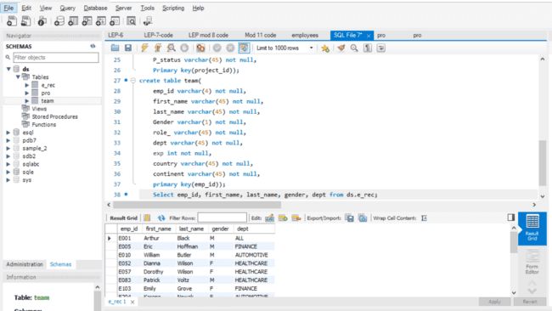

1. Emp_rating < 2:

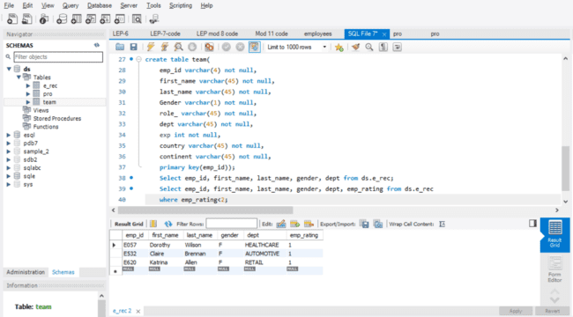

1. Emp Rating < 4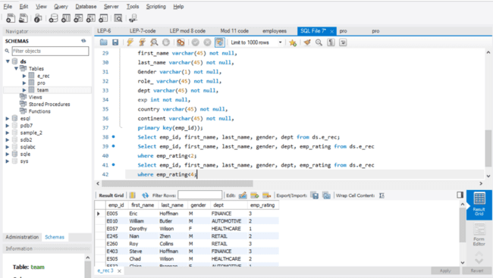
2. Emp rating between 2 & 4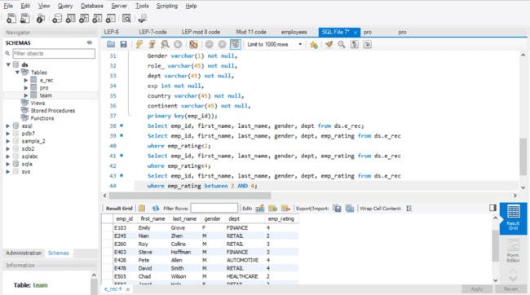
3. Concatenate names: 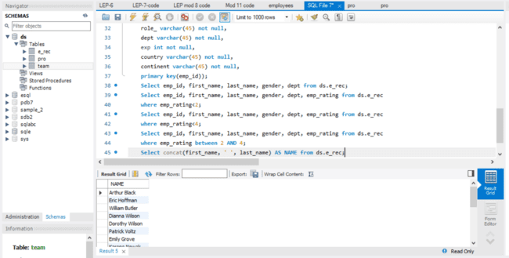
4. Employees who have someone reporting to them: 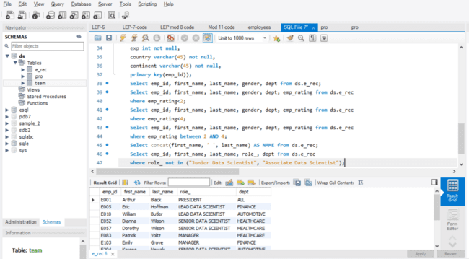
5. Count of reporters: 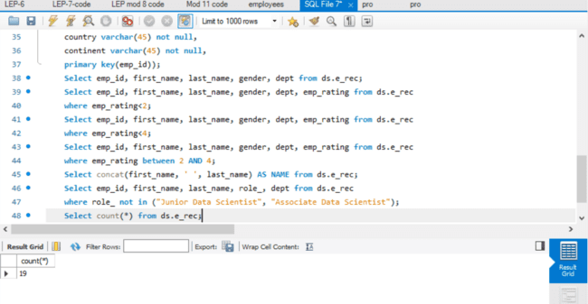
6. Employees in healthcare and finance using UNION: 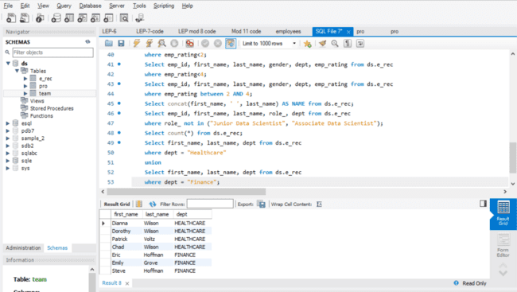
7. Group employees by dept and determine max rating in each department: 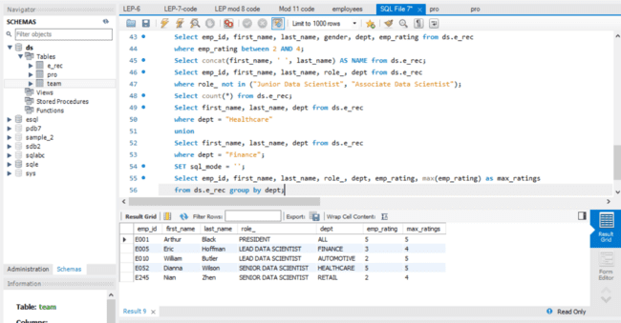
8. Calculate minimum and maximum salary: 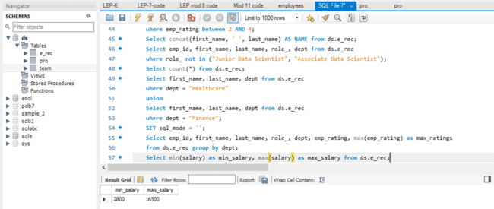
9. Ranking employees based on their experience: 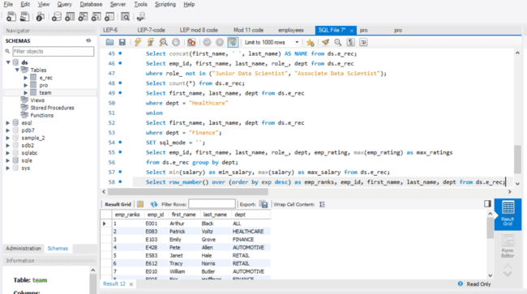
10. Employee with Salary>6000 from various countries using a view: 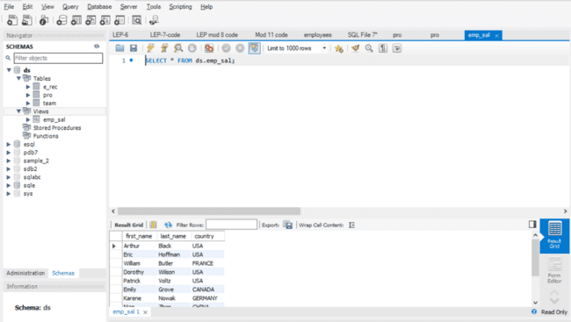
11. Exp>10 years using nested query: 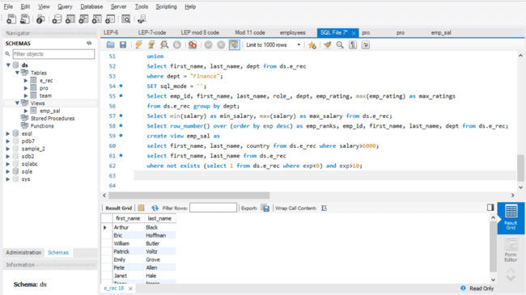
12. Stored procedure for emp with exp>3: 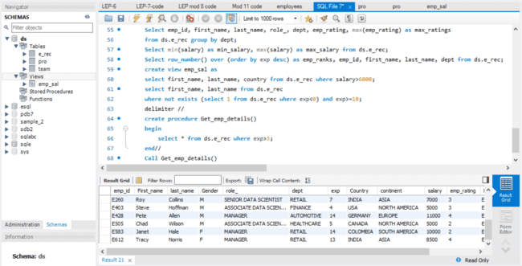
13. Write a query using stored functions in the project table to check whether the job profile assigned to each employee in the data science team matches the organization’s set standard.
14. Write a query using stored functions in the project table to check whether the job profile assigned to each employee in the data science team matches the organization’s set standard: 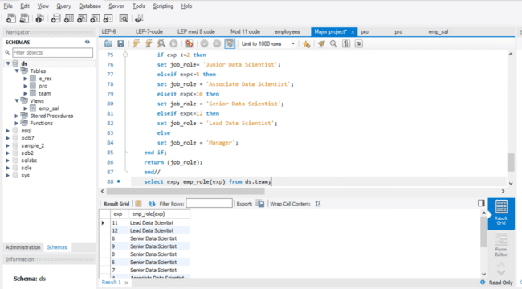
15. Create an index to improve the cost and performance of the query to find the employee whose FIRST_NAME is ‘Eric’ in the employee table after checking the execution plan. 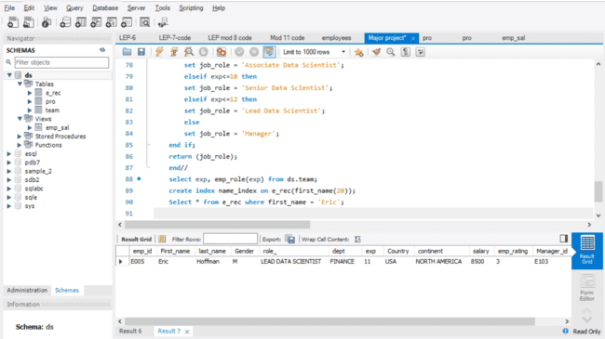
16. Write a query to calculate the bonus for all the employees, based on their ratings and salaries (Use the formula: 5% of salary * employee rating). 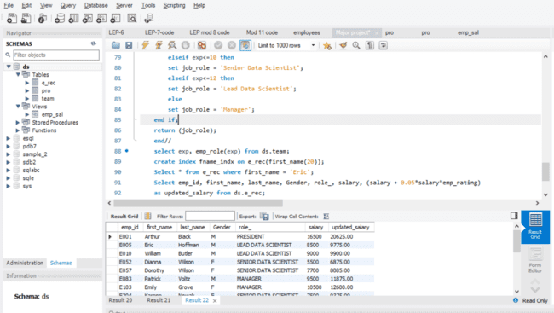
17. Write a query to calculate the average salary distribution based on the continent and country. Take data from the employee record table. 